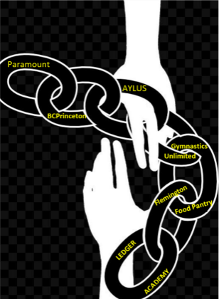
BCPrinceton’s
SUMMER BLOCKCHAIN PROJECT
The Giving Chain
Collection Location: Gymnastics Unlimited
2 Lilac Dr, Flemington, NJ 08822
Get involved for Social Good This Summer!! | Blockchain Princeton and Ledger Academy are encouraging donations for local residence in need. Please drop off a donation and give back to your community!
Pickup Date | August 25, 2019
Donation Suggestions:  Toothbrushes (Children’s)  Razors / Shaving Cream  Creamy Peanut Butter  Vegetable Soup  Canned Chicken  Canned Fruit  Dog and Cat Food  Feminine Hygiene Products  Depends | THANK YOU  SPONSORS  Hyperledger 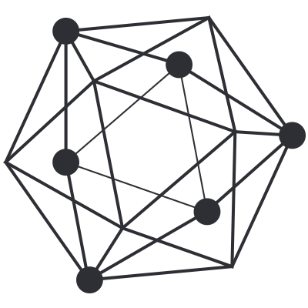
BCPrinceton’s
SUMMER BLOCKCHAIN PROJECT
The Giving Chain
Collection Location: Gymnastics Unlimited
Tiger Labs 252 Nassau Street Princeton, NJ 08540
Get involved for Social Good This Summer!! | Blockchain Princeton and Ledger Academy are encouraging donations for local residence in need. Please drop off a donation and give back to your community!
Pickup Date | August 25, 2019
Donation Suggestions:  Toothbrushes (Children’s)  Razors / Shaving Cream  Creamy Peanut Butter  Vegetable Soup  Canned Chicken  Canned Fruit  Dog and Cat Food  Feminine Hygiene Products  Depends | THANK YOU  SPONSORS  Hyperledger

